**ASSIGNMENT - 4**

**Problem Statement :- SMS SPAM Classification**

|  |  |
| --- | --- |
| **Assignment Date** | **29 October 2022** |
| **Student Name** | **M.HARI PRASAD** |
| **Student Reg Number** | **737819ECR049** |
| **Maximum Marks** | **2 Marks** |

1. **Download the Data set:- Data set**

**https://**[**www.kaggle.com/code/kredy10/simple-lstm-for-text-**](http://www.kaggle.com/code/kredy10/simple-lstm-for-text-) **classification/data**

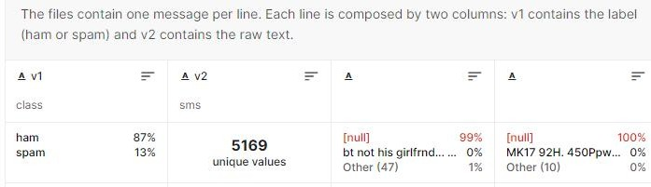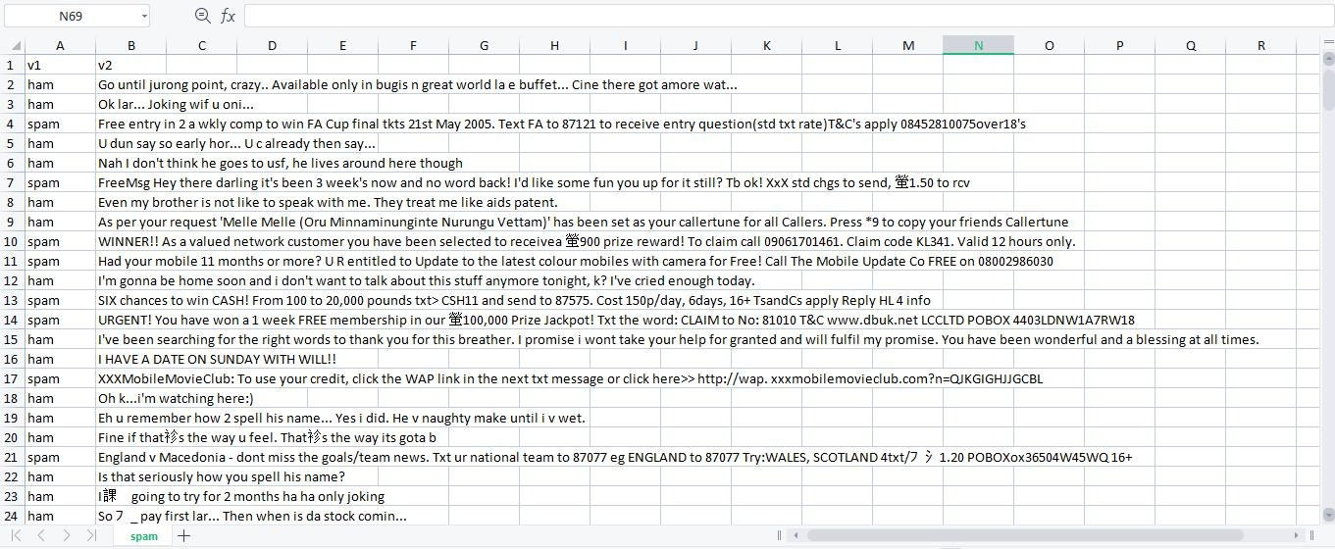

1. **Import required library**

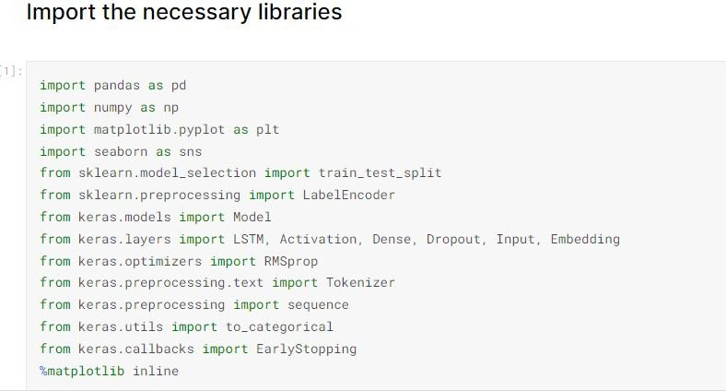

1. **Read dataset and do pre-processing**

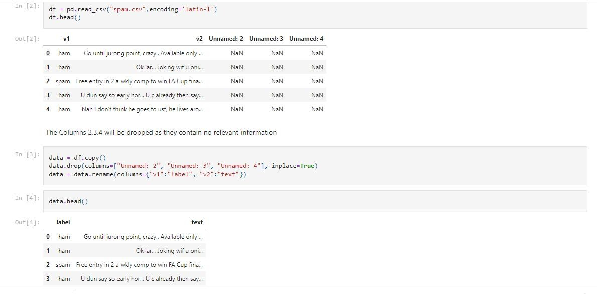

Preproceesing:

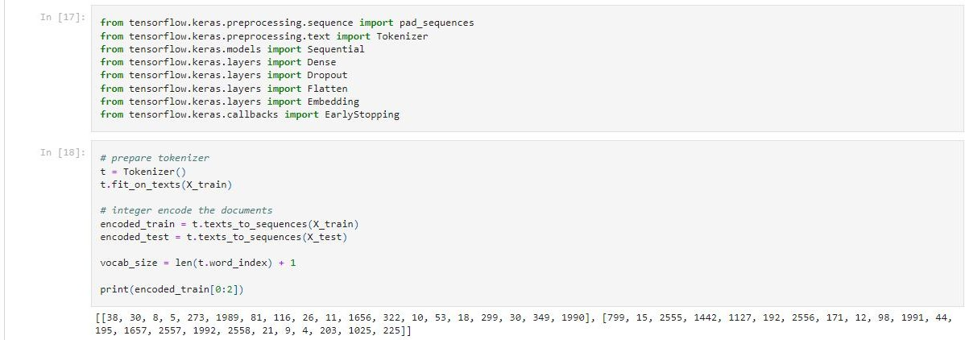

1. **Create Model**

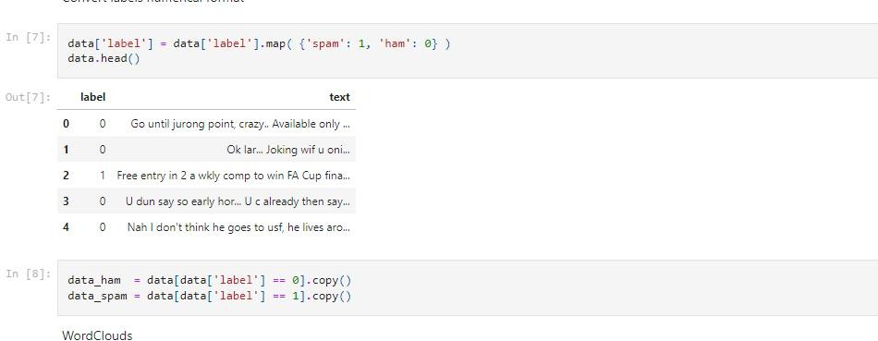

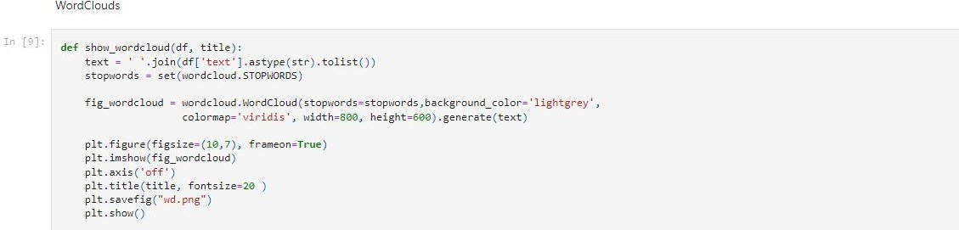

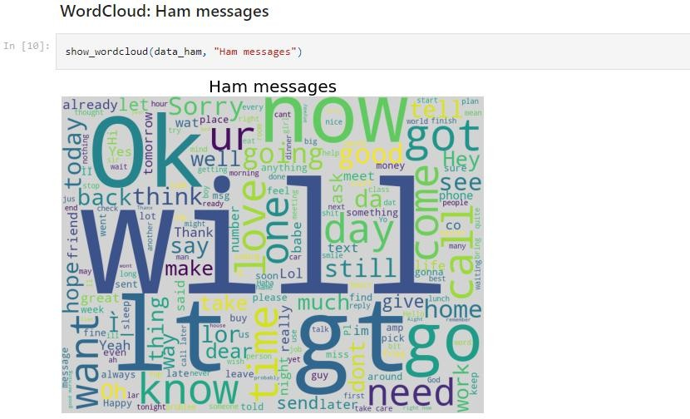

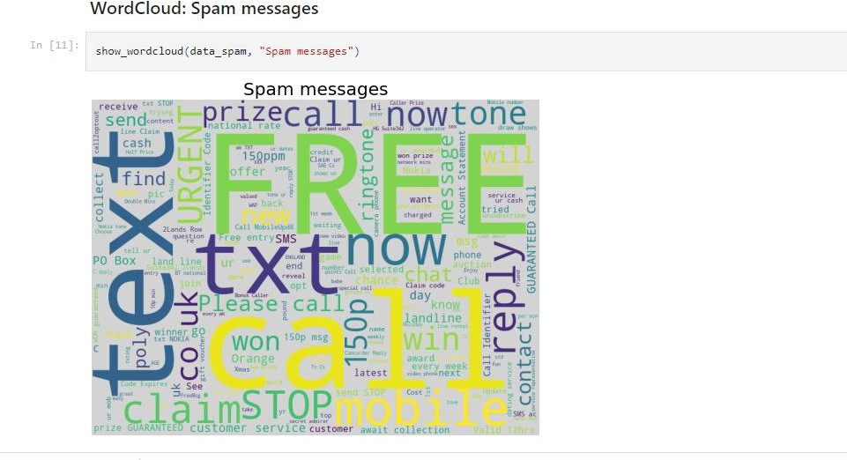

1. **Add Layers (LSTM, Dense-(Hidden Layers), Output)**
2. **Compile the Mode**l

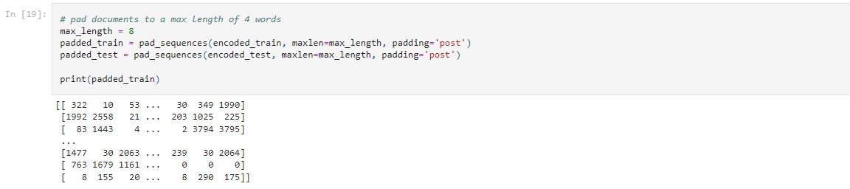

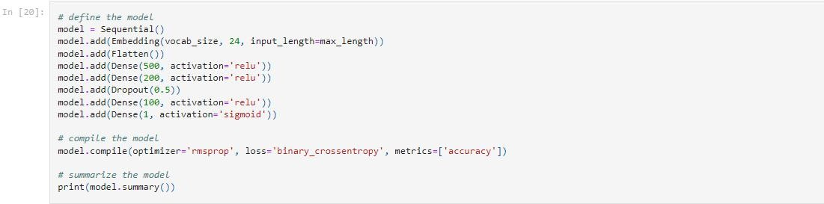

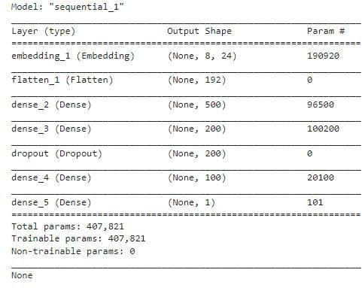

1. **Fit the Model**

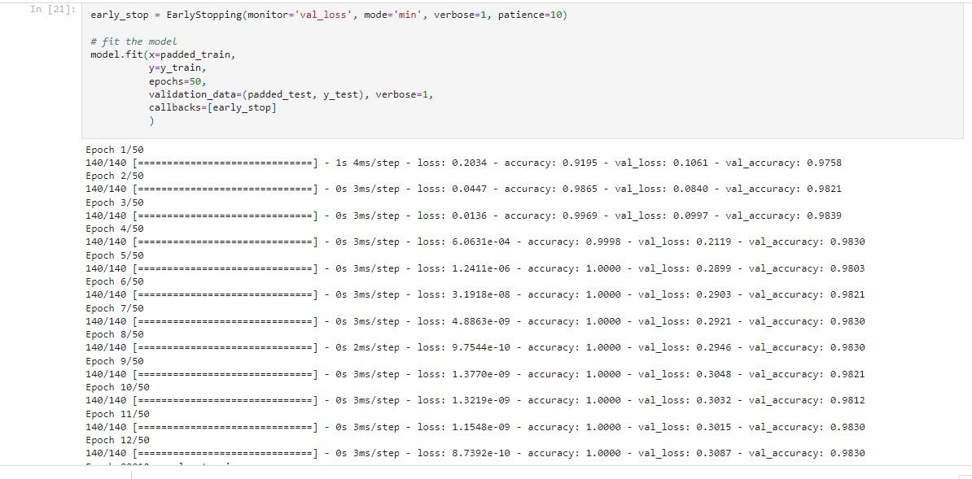

1. **Save The Model**

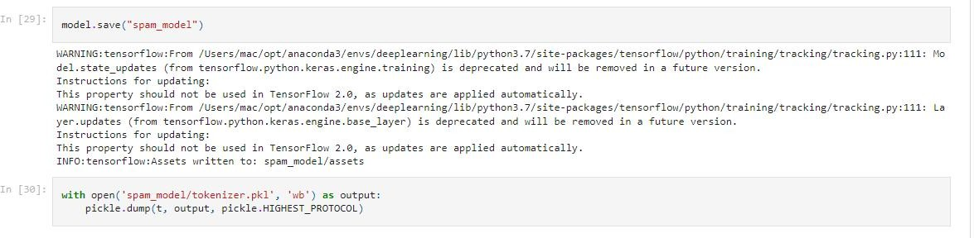

1. **Test The Model**

